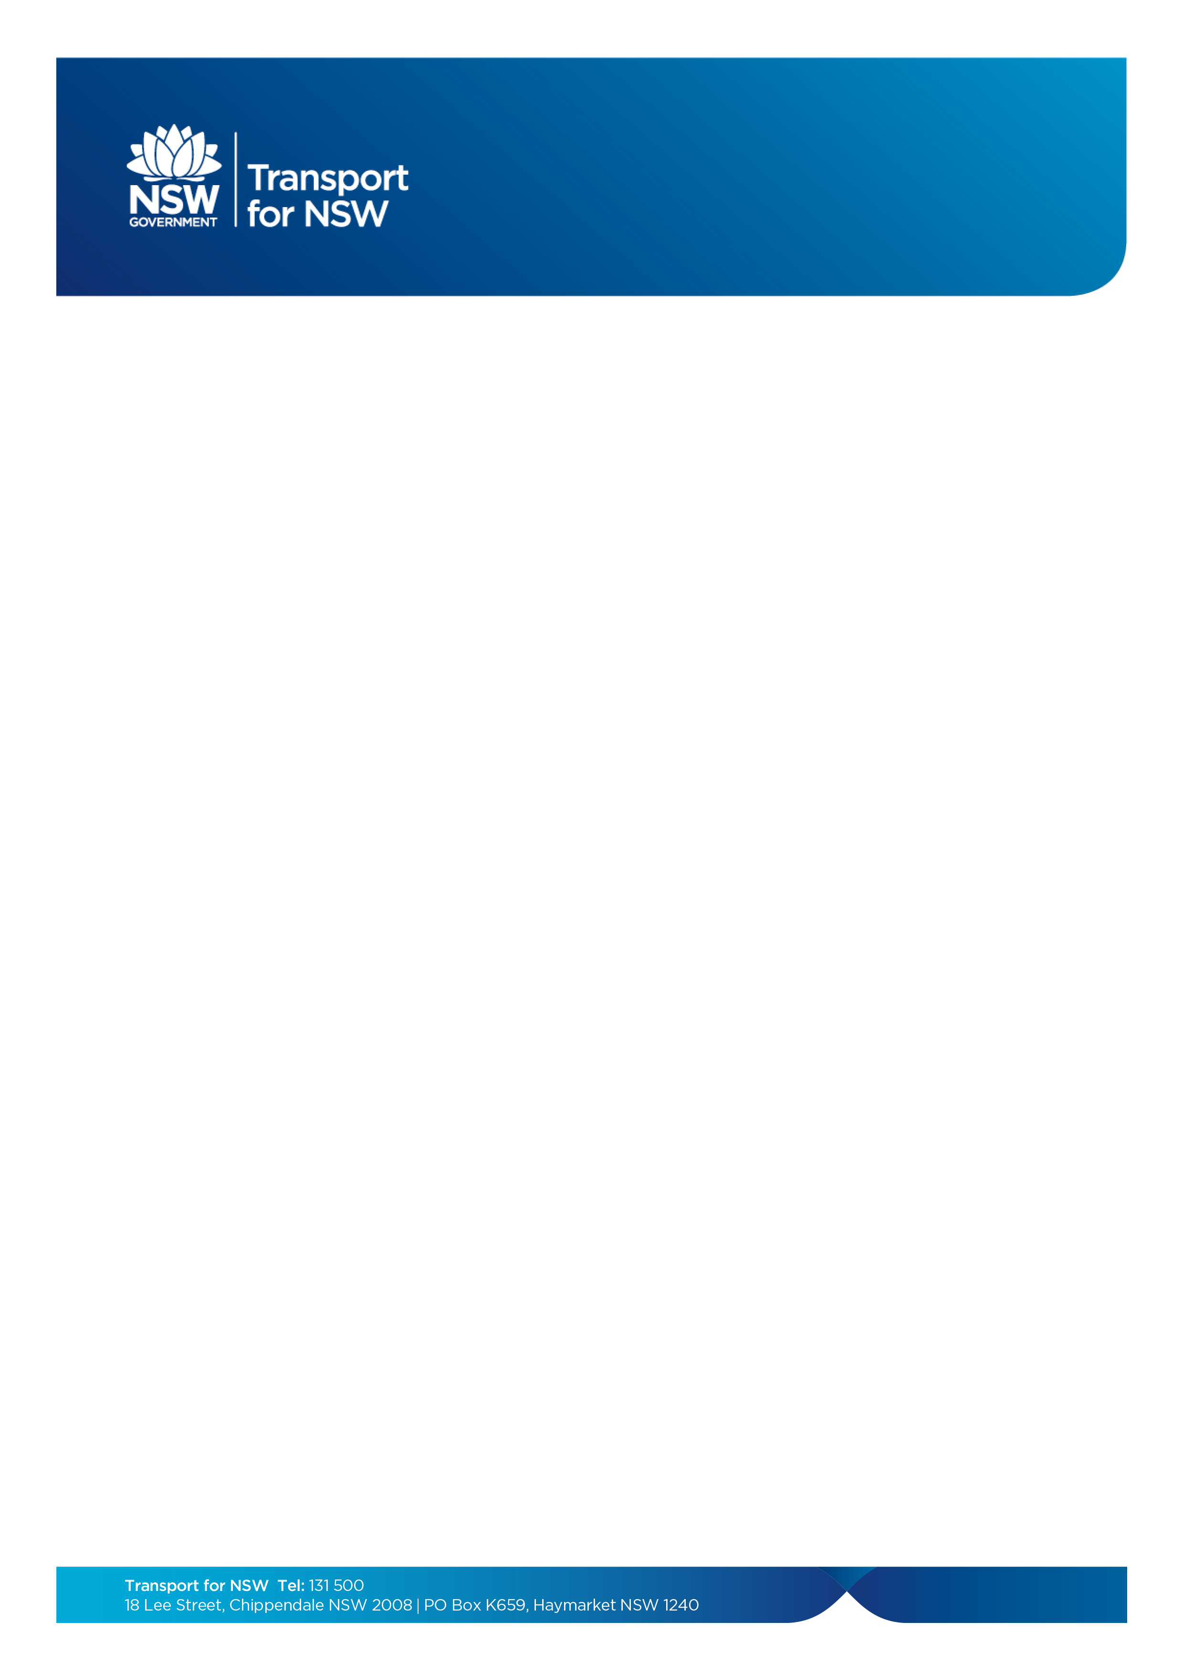
Asylum seeker

Designated Agencies

Updated January 2022

Designated Agency | Address | Phone
Asylum Seeker Program (ASP),  St Vincent De Paul Society | 99 Forbes Street  Woolloomooloo NSW 2011  Postal address:  PO Box 180  Kings Cross NSW 1340 | (02) 8622 0419  or  Mobile: 0429 721 627
Asylum Seekers Centre | 43 Bedford Street  Newtown NSW 2042 | (02) 9078 1900
Australian Red Cross | Sydney:  Level 3, 464 Kent Street  Sydney NSW 2000  Wagga Wagga:  88 Murray St  Wagga Wagga NSW 2650 | (02) 9229 4266  (02) 5963 2952
House of Welcome | 140 Wattle Avenue  Carramar NSW 2163 | (02) 9727 9290
Jesuit Refugee Service | Arrupe Place  10-12 Victoria Road  Parramatta NSW 2150  24 Roslyn Street  Kings Cross NSW 2011 | (02) 9098 9336  (02) 9356 3888
Life Without Barriers | Suite 1, Level 1  81 Railway Street  Rockdale NSW 2216  Suite 105 & 106,  Level 1, 30 Cowper Street Parramatta NSW 2150 | (02) 9508 4000  (02) 8830 7600
NSW Refugee Health Service | Suite 1, Level 3  157-161 George Street  Liverpool NSW 2170  Suite 201, Level 2  1-7 Moore Street  Liverpool NSW 2170  Postal address:  PO Box 144  Liverpool BC NSW 1871 | (02) 9794 0770

(continued on next page)

Asylum Seeker

Designated agencies
Updated January 2022
(continued from previous page)
Designated Agency | Address | Phone
NSW Service for the Treatment and Rehabilitation of Torture and Trauma Survivors (STARTTS)  STARTTS also provides outreach services in a range of locations across the Sydney metropolitan area and regional NSW. Please contact the Carramar office for outreach locations. | Newcastle area:  Longsworth Avenue  Wallsend NSW 2287  Newcastle TAFE (Tighes Hill)  Building M, Room 116-118  Tighes Hill NSW 2297  Wollongong area:  Wollongong TAFE  Building K, Ground Floor,  Rooms 6 and 12  Foleys Lane  North Wollongong  Illawarra Multicultural Services (IMS)  7 Auburn St,  Wollongong  Coffs Harbour:  14 Earl Street  Coffs Harbour NSW 2450  Wagga Wagga:  12 Station Place  Wagga Wagga NSW 2650 | (02) 4923 7194 or  (02) 4923 7190  0477 718 213 or  0409 709 584  (02) 6650 9195  (02) 6921 4403 or  (02) 6971 7640
Serco SRSS | 15 Birmingham avenue  Villawood NSW 2163 | 0437 498 302
Settlement Services International | 2/158 Liverpool Road Ashfield NSW 2131  2/462 Chapel Road, Bankstown NSW 2200  1/81 George Street  Parramatta NSW 2150 | (02) 8799 6700  (02) 8713 9200  (02) 9685 0100

